Lepidoptera_code

Elsa Heywood

2024-03-18

Load in the data

library(readxl)  
# Read Excel data into a data frame named Project_data_copynew  
Project_data_copynew <- read_excel("/Users/elsaheywood/Desktop/Project_data_copynew.xlsx", sheet = "Sheet1")

Checks that my dataset isn’t biased

Check the coverage of my data

library(ggplot2)  
ggplot(Project_data_copynew, aes(x = Year)) +  
 geom_bar(fill = "#2895F5", width = 0.7) + # Set the width of bars to 0.7  
 labs(title = "Coverage of Specimens Across Years", x = "Year", y = "Count") +  
 theme_minimal()

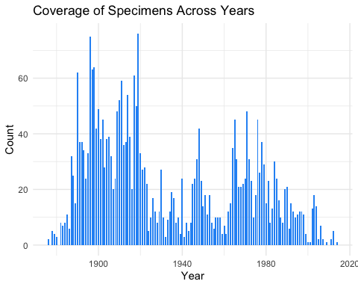

Add latitude as a continuous variable to dataset

midpoints <- c(1.5, 2.5, 3.5, 4.5, 5.5, 6.5, 7.5, 8.5, 9.5)  
Project_data_copynew$Latitude_Continuous <- midpoints[Project_data_copynew$Lattitude_Group]

Check species shifting latitude over time isn’t causing effects

library(ggplot2)  
library(colorspace)  
  
# Generate a color palette with 29 distinct colors  
species_palette <- rainbow_hcl(29)  
  
# Plot Latitude_Continuous against Year, with different lines for each Species  
ggplot(Project_data_copynew, aes(x = Year, y = Latitude_Continuous, color = Species)) +  
 geom_point() +  
 scale_color_manual(values = species_palette) +  
 labs(x = "Year", y = "Latitude Group", color = "Species") +  
 theme_minimal() +  
 facet_wrap(~Species)+  
 geom_smooth(col='black')+guides(col='none')

## `geom_smooth()` using method = 'loess' and formula = 'y ~ x'

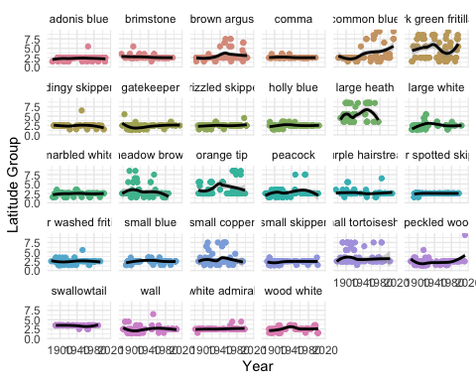

Z transform my data by species

library(dplyr)

##   
## Attaching package: 'dplyr'

## The following objects are masked from 'package:stats':  
##   
## filter, lag

## The following objects are masked from 'package:base':  
##   
## intersect, setdiff, setequal, union

# Define a function for log transformation  
scale_this <- function(x){  
 (x - mean(x, na.rm=TRUE)) / sd(x, na.rm=TRUE)  
}  
  
unscale_this <- function(x, sd_z, mean_z){  
 (x - mean(x, na.rm=TRUE)) / sd(x, na.rm=TRUE)  
}  
  
# Applying custom scaling function within each group  
Project_data_copynew <-   
 Project_data_copynew %>%  
 group_by(Species) %>%  
 mutate(Z_Forewing_Area = scale_this(Forewing_Area),  
 Z_Wing_Length = scale_this(Wing_Length),  
 Z_Abdomen_Length = scale_this(Abdomen_Length),  
 Z_Abdomen_Width = scale_this(Abdomen_Width))

Examine the overall changes over time Build the models

area_model <- lm(Z_Forewing_Area ~ Year, data = Project_data_copynew)  
abwidth_model <- lm(Z_Abdomen_Width ~ Year, data = Project_data_copynew)  
wing_length_model <- lm(Z_Wing_Length ~ Year, data = Project_data_copynew)  
ablength_model <- lm(Z_Abdomen_Length ~ Year, data = Project_data_copynew)

Look at results

summary(area_model)

##   
## Call:  
## lm(formula = Z_Forewing_Area ~ Year, data = Project_data_copynew)  
##   
## Residuals:  
## Min 1Q Median 3Q Max   
## -5.7436 -0.6938 -0.0228 0.6707 3.2266   
##   
## Coefficients:  
## Estimate Std. Error t value Pr(>|t|)   
## (Intercept) -4.5312293 1.0276676 -4.409 1.08e-05 ***  
## Year 0.0023445 0.0005316 4.410 1.07e-05 ***  
## ---  
## Signif. codes: 0 '***' 0.001 '**' 0.01 '*' 0.05 '.' 0.1 ' ' 1  
##   
## Residual standard error: 0.9921 on 2884 degrees of freedom  
## Multiple R-squared: 0.006698, Adjusted R-squared: 0.006354   
## F-statistic: 19.45 on 1 and 2884 DF, p-value: 1.072e-05

summary(abwidth_model)

##   
## Call:  
## lm(formula = Z_Abdomen_Width ~ Year, data = Project_data_copynew)  
##   
## Residuals:  
## Min 1Q Median 3Q Max   
## -3.2531 -0.7487 -0.1097 0.6321 4.7523   
##   
## Coefficients:  
## Estimate Std. Error t value Pr(>|t|)   
## (Intercept) -4.7855242 1.0272677 -4.658 3.33e-06 ***  
## Year 0.0024761 0.0005314 4.659 3.32e-06 ***  
## ---  
## Signif. codes: 0 '***' 0.001 '**' 0.01 '*' 0.05 '.' 0.1 ' ' 1  
##   
## Residual standard error: 0.9918 on 2884 degrees of freedom  
## Multiple R-squared: 0.007471, Adjusted R-squared: 0.007127   
## F-statistic: 21.71 on 1 and 2884 DF, p-value: 3.318e-06

summary(wing_length_model)

##   
## Call:  
## lm(formula = Z_Wing_Length ~ Year, data = Project_data_copynew)  
##   
## Residuals:  
## Min 1Q Median 3Q Max   
## -7.3807 -0.6683 -0.0037 0.6728 3.2199   
##   
## Coefficients:  
## Estimate Std. Error t value Pr(>|t|)   
## (Intercept) -4.8676182 1.0271339 -4.739 2.25e-06 ***  
## Year 0.0025186 0.0005314 4.740 2.24e-06 ***  
## ---  
## Signif. codes: 0 '***' 0.001 '**' 0.01 '*' 0.05 '.' 0.1 ' ' 1  
##   
## Residual standard error: 0.9916 on 2884 degrees of freedom  
## Multiple R-squared: 0.00773, Adjusted R-squared: 0.007385   
## F-statistic: 22.47 on 1 and 2884 DF, p-value: 2.243e-06

summary(ablength_model)

##   
## Call:  
## lm(formula = Z_Abdomen_Length ~ Year, data = Project_data_copynew)  
##   
## Residuals:  
## Min 1Q Median 3Q Max   
## -3.9603 -0.6689 0.0209 0.7013 3.4979   
##   
## Coefficients:  
## Estimate Std. Error t value Pr(>|t|)   
## (Intercept) -7.870439 1.020655 -7.711 1.70e-14 ***  
## Year 0.004072 0.000528 7.712 1.69e-14 ***  
## ---  
## Signif. codes: 0 '***' 0.001 '**' 0.01 '*' 0.05 '.' 0.1 ' ' 1  
##   
## Residual standard error: 0.9854 on 2884 degrees of freedom  
## Multiple R-squared: 0.02021, Adjusted R-squared: 0.01987   
## F-statistic: 59.48 on 1 and 2884 DF, p-value: 1.688e-14

Visualise wing area over time

#load ggplot  
library(ggplot2)  
library(broom)  
  
# Extract coefficients and p-value  
area_model_summary <- tidy(area_model)  
  
# Filter the p-value for the specific coefficient you are interested in  
# Let's say you want the p-value for the coefficient of Year  
p_value <- area_model_summary$p.value[area_model_summary$term == "Year"]  
  
# Create the plot  
ggplot(Project_data_copynew, aes(x = Year, y = Z_Forewing_Area, color = Species)) +  
 geom_point() + # Scatter plot  
 geom_smooth(method = "lm", se = FALSE, formula = y ~ x, color = "black") + # Overall regression line  
 annotate("text", x = max(Project_data_copynew$Year),  
 y = max(Project_data_copynew$Z_Forewing_Area),  
 label = paste("p-value =", formatC(p_value, digits = 2)),  
 hjust = 1, vjust = 0.1, size = 4, color = "black") + # Add p-value text  
 labs(title = " Z Forewing Area Changes Over Time by Species",  
 x = "Year",  
 y = "Z Forewing Area",  
 color = "Species") +  
 theme_minimal()

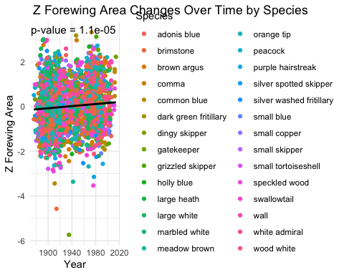 Visualise abdomen width over time

#load ggplot  
library(ggplot2)  
library(broom)  
  
# Extract coefficients and p-value  
abwidth_model_summary <- tidy(abwidth_model)  
  
# Filter the p-value for the specific coefficient you are interested in  
# Let's say you want the p-value for the coefficient of Year  
p_value <- abwidth_model_summary$p.value[abwidth_model_summary$term == "Year"]  
  
# Create the plot  
ggplot(Project_data_copynew, aes(x = Year, y = Z_Abdomen_Width, color = Species)) +  
 geom_point() + # Scatter plot  
 geom_smooth(method = "lm", se = FALSE, formula = y ~ x, color = "black") + # Overall regression line  
 annotate("text", x = max(Project_data_copynew$Year),  
 y = max(Project_data_copynew$Z_Abdomen_Width),  
 label = paste("p-value =", formatC(p_value, digits = 2)),  
 hjust = 1, vjust = 0.1, size = 4, color = "black") + # Add p-value text  
 labs(title = " Z Abdomen Width Changes Over Time by Species",  
 x = "Year",  
 y = "Z Abdomen Width",  
 color = "Species") +  
 theme_minimal()

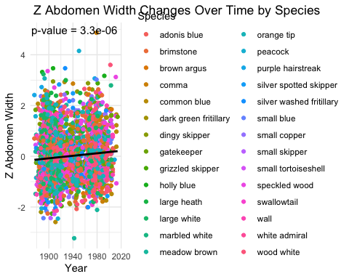 Visualise what individual species are doing over time

#forewing area  
Project_data_copynew %>%  
 ggplot(aes(y = Forewing_Area, x = Year)) +  
 geom_point() +  
 geom_smooth(method = "lm", se = FALSE) + # Add regression line  
 facet_wrap(~Species, scales = 'free_y')

## `geom_smooth()` using formula = 'y ~ x'

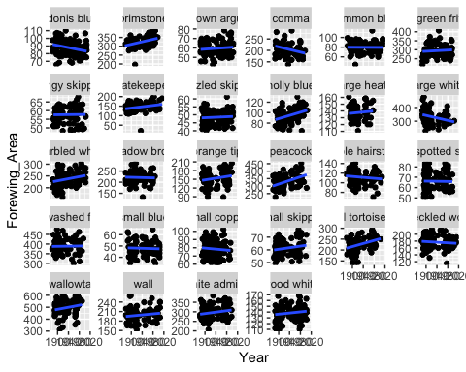

#abdomen width  
Project_data_copynew %>%  
 ggplot(aes(y = Abdomen_Width, x = Year)) +  
 geom_point() +  
 geom_smooth(method = "lm", se = FALSE) + # Add regression line  
 facet_wrap(~Species, scales = 'free_y')

## `geom_smooth()` using formula = 'y ~ x'

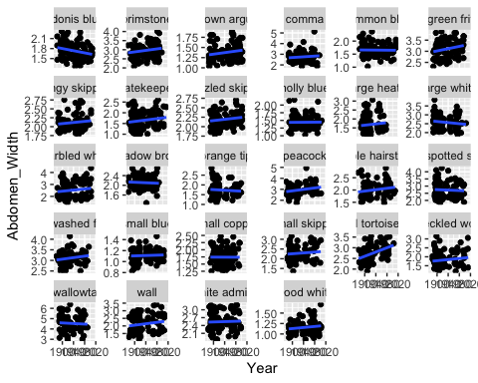 Looking at the rates of change in each species across the time period

library(dplyr)  
library(broom)  
library(tidyr)  
  
# Define a function to calculate the overall rate of change for each species  
calculate_overall_rate_per_species <- function(Project_data_copynew, Forewing_Area) {  
 species_data <- split(Project_data_copynew, Project_data_copynew$Species)  
 overall_rates <- sapply(species_data, function(sub_data) {  
 model <- lm(substitute(Forewing_Area ~ Year), data = sub_data)  
 coef(model)["Year"]  
 })  
 overall_rates_df <- data.frame(Species = names(overall_rates), Overall_Rate = overall_rates, row.names = NULL)  
 return(overall_rates_df)  
}  
  
# Calculate the overall rate of change for each species for Forewing_Area using your data  
forewing_overall_rate_per_species <- calculate_overall_rate_per_species(Project_data_copynew, Project_data_copynew$Forewing_Area)  
  
# Print the table  
print(forewing_overall_rate_per_species)

## Species Overall_Rate  
## 1 adonis blue.Year -0.070950075  
## 2 brimstone.Year 0.353526710  
## 3 brown argus.Year 0.019823810  
## 4 comma.Year -0.286029565  
## 5 common blue.Year -0.002609897  
## 6 dark green fritillary.Year 0.079596642  
## 7 dingy skipper.Year 0.001676416  
## 8 gatekeeper.Year 0.174317254  
## 9 grizzled skipper.Year 0.007624134  
## 10 holly blue.Year 0.154036276  
## 11 large heath.Year 0.039570035  
## 12 large white.Year -0.453304438  
## 13 marbled white.Year 0.219655159  
## 14 meadow brown.Year -0.032183449  
## 15 orange tip.Year 0.147166751  
## 16 peacock.Year 0.608650698  
## 17 purple hairstreak.Year -0.048097673  
## 18 silver spotted skipper.Year -0.003947382  
## 19 silver washed fritillary.Year 0.020109134  
## 20 small blue.Year -0.007013305  
## 21 small copper.Year -0.029772857  
## 22 small skipper.Year 0.030899212  
## 23 small tortoiseshell.Year 0.350691661  
## 24 speckled wood.Year -0.045241115  
## 25 swallowtail.Year 0.427836606  
## 26 wall.Year 0.081455039  
## 27 white admiral.Year 0.188598206  
## 28 wood white.Year 0.049442729

##same for abdomen width  
calculate_overall_rate_per_species_ab <- function(Project_data_copynew, Abdomen_Width) {  
 species_data_ab <- split(Project_data_copynew, Project_data_copynew$Species)  
 overall_rates_ab <- sapply(species_data_ab, function(sub_data) {  
 model <- lm(substitute(Abdomen_Width ~ Year), data = sub_data)  
 coef(model)["Year"]  
 })  
 overall_rates_df_ab <- data.frame(Species = names(overall_rates_ab), Overall_Rate = overall_rates_ab, row.names = NULL)  
 return(overall_rates_df_ab)  
}  
  
# Calculate the overall rate of change for each species for Abdomen width using your data  
ab_overall_rate_per_species <- calculate_overall_rate_per_species_ab(Project_data_copynew, Project_data_copynew$Abdomen_Width)  
  
# Print the table  
print(ab_overall_rate_per_species)

## Species Overall_Rate  
## 1 adonis blue.Year -1.625252e-03  
## 2 brimstone.Year 2.058420e-03  
## 3 brown argus.Year 9.360427e-04  
## 4 comma.Year 1.671469e-03  
## 5 common blue.Year -1.002515e-04  
## 6 dark green fritillary.Year 2.561640e-03  
## 7 dingy skipper.Year 7.861860e-04  
## 8 gatekeeper.Year 1.643793e-03  
## 9 grizzled skipper.Year 8.368661e-04  
## 10 holly blue.Year 7.737173e-05  
## 11 large heath.Year 1.781430e-03  
## 12 large white.Year -1.549998e-03  
## 13 marbled white.Year 2.337172e-03  
## 14 meadow brown.Year -4.831095e-04  
## 15 orange tip.Year -7.870948e-04  
## 16 peacock.Year 3.289628e-03  
## 17 purple hairstreak.Year 1.439639e-03  
## 18 silver spotted skipper.Year -7.953321e-04  
## 19 silver washed fritillary.Year 1.780966e-03  
## 20 small blue.Year 1.563999e-04  
## 21 small copper.Year -3.305255e-05  
## 22 small skipper.Year 1.060957e-03  
## 23 small tortoiseshell.Year 4.994091e-03  
## 24 speckled wood.Year 1.561916e-03  
## 25 swallowtail.Year -1.400585e-03  
## 26 wall.Year 2.373932e-03  
## 27 white admiral.Year 3.234167e-04  
## 28 wood white.Year 6.275617e-04

What factors explain these changes? main model

multiple regression on forewing area and abdomen width

multiple_model <- lm(Z_Forewing_Area ~Year + Temperature_Before + Ecology + Latitude_Continuous + Family + Family*Year + Ecology*Year + Ecology*Temperature_Before, data = Project_data_copynew)  
  
multiple_model_ab <- lm(Z_Abdomen_Width ~Year + Temperature_Before + Ecology + Latitude_Continuous + Family + Family*Year + Ecology*Year + Ecology*Temperature_Before, data = Project_data_copynew)

Examine results

summary(multiple_model)

##   
## Call:  
## lm(formula = Z_Forewing_Area ~ Year + Temperature_Before + Ecology +   
## Latitude_Continuous + Family + Family * Year + Ecology *   
## Year + Ecology * Temperature_Before, data = Project_data_copynew)  
##   
## Residuals:  
## Min 1Q Median 3Q Max   
## -5.7437 -0.6870 -0.0299 0.6755 3.2871   
##   
## Coefficients:  
## Estimate Std. Error t value Pr(>|t|)   
## (Intercept) -1.289e+00 3.093e+00 -0.417 0.6768   
## Year 8.817e-04 1.612e-03 0.547 0.5845   
## Temperature_Before -3.323e-02 3.786e-02 -0.878 0.3802   
## EcologyGS -5.848e+00 2.559e+00 -2.286 0.0224 *  
## EcologySS 3.738e+00 2.795e+00 1.338 0.1811   
## Latitude_Continuous -7.509e-03 1.886e-02 -0.398 0.6905   
## FamilyLycaenidae 2.699e+00 3.385e+00 0.797 0.4253   
## FamilyNymphalidae -5.642e+00 3.171e+00 -1.779 0.0753 .  
## FamilyPapilionidae -1.474e+01 7.962e+00 -1.851 0.0643 .  
## FamilyPieridae -3.881e+00 3.968e+00 -0.978 0.3282   
## Year:FamilyLycaenidae -1.396e-03 1.749e-03 -0.798 0.4251   
## Year:FamilyNymphalidae 2.920e-03 1.641e-03 1.780 0.0753 .  
## Year:FamilyPapilionidae 7.632e-03 4.124e-03 1.850 0.0643 .  
## Year:FamilyPieridae 1.994e-03 2.050e-03 0.973 0.3306   
## Year:EcologyGS 2.973e-03 1.329e-03 2.236 0.0254 *  
## Year:EcologySS -1.852e-03 1.460e-03 -1.268 0.2047   
## Temperature_Before:EcologyGS 7.879e-03 5.311e-02 0.148 0.8821   
## Temperature_Before:EcologySS -1.318e-02 5.625e-02 -0.234 0.8148   
## ---  
## Signif. codes: 0 '***' 0.001 '**' 0.01 '*' 0.05 '.' 0.1 ' ' 1  
##   
## Residual standard error: 0.9903 on 2867 degrees of freedom  
## (1 observation deleted due to missingness)  
## Multiple R-squared: 0.01557, Adjusted R-squared: 0.009732   
## F-statistic: 2.667 on 17 and 2867 DF, p-value: 0.0002349

anova(multiple_model)

## Analysis of Variance Table  
##   
## Response: Z_Forewing_Area  
## Df Sum Sq Mean Sq F value Pr(>F)   
## Year 1 18.88 18.8815 19.2542 1.186e-05 ***  
## Temperature_Before 1 1.33 1.3262 1.3524 0.244961   
## Ecology 2 0.09 0.0425 0.0434 0.957546   
## Latitude_Continuous 1 0.30 0.2982 0.3040 0.581398   
## Family 4 0.20 0.0490 0.0500 0.995322   
## Year:Family 4 13.50 3.3748 3.4414 0.008182 **   
## Year:Ecology 2 10.05 5.0246 5.1237 0.006008 **   
## Temperature_Before:Ecology 2 0.13 0.0648 0.0660 0.936102   
## Residuals 2867 2811.51 0.9806   
## ---  
## Signif. codes: 0 '***' 0.001 '**' 0.01 '*' 0.05 '.' 0.1 ' ' 1

summary(multiple_model_ab)

##   
## Call:  
## lm(formula = Z_Abdomen_Width ~ Year + Temperature_Before + Ecology +   
## Latitude_Continuous + Family + Family * Year + Ecology *   
## Year + Ecology * Temperature_Before, data = Project_data_copynew)  
##   
## Residuals:  
## Min 1Q Median 3Q Max   
## -3.2946 -0.7392 -0.0988 0.6359 4.6544   
##   
## Coefficients:  
## Estimate Std. Error t value Pr(>|t|)   
## (Intercept) -2.3474054 3.0888623 -0.760 0.44734   
## Year 0.0012360 0.0016103 0.768 0.44281   
## Temperature_Before -0.0008380 0.0378104 -0.022 0.98232   
## EcologyGS -6.6570664 2.5555495 -2.605 0.00924 **  
## EcologySS 5.1983519 2.7912452 1.862 0.06265 .   
## Latitude_Continuous -0.0108583 0.0188329 -0.577 0.56428   
## FamilyLycaenidae 1.1459873 3.3806258 0.339 0.73464   
## FamilyNymphalidae -5.8976008 3.1669682 -1.862 0.06267 .   
## FamilyPapilionidae 1.4667313 7.9526778 0.184 0.85369   
## FamilyPieridae 1.7150712 3.9635473 0.433 0.66526   
## Year:FamilyLycaenidae -0.0005918 0.0017473 -0.339 0.73488   
## Year:FamilyNymphalidae 0.0030561 0.0016390 1.865 0.06235 .   
## Year:FamilyPapilionidae -0.0007533 0.0041193 -0.183 0.85492   
## Year:FamilyPieridae -0.0008925 0.0020471 -0.436 0.66290   
## Year:EcologyGS 0.0034387 0.0013279 2.590 0.00966 **  
## Year:EcologySS -0.0020790 0.0014586 -1.425 0.15417   
## Temperature_Before:EcologyGS 0.0008517 0.0530478 0.016 0.98719   
## Temperature_Before:EcologySS -0.1014019 0.0561826 -1.805 0.07120 .   
## ---  
## Signif. codes: 0 '***' 0.001 '**' 0.01 '*' 0.05 '.' 0.1 ' ' 1  
##   
## Residual standard error: 0.9891 on 2867 degrees of freedom  
## (1 observation deleted due to missingness)  
## Multiple R-squared: 0.01851, Adjusted R-squared: 0.01269   
## F-statistic: 3.18 on 17 and 2867 DF, p-value: 1.106e-05

anova(multiple_model_ab)

## Analysis of Variance Table  
##   
## Response: Z_Abdomen_Width  
## Df Sum Sq Mean Sq F value Pr(>F)   
## Year 1 21.26 21.2615 21.7326 3.277e-06 ***  
## Temperature_Before 1 0.54 0.5422 0.5542 0.4566772   
## Ecology 2 0.06 0.0317 0.0324 0.9681052   
## Latitude_Continuous 1 0.32 0.3228 0.3300 0.5657043   
## Family 4 0.27 0.0674 0.0689 0.9913401   
## Year:Family 4 12.16 3.0412 3.1086 0.0145382 *   
## Year:Ecology 2 14.31 7.1536 7.3121 0.0006799 ***  
## Temperature_Before:Ecology 2 3.96 1.9799 2.0238 0.1323413   
## Residuals 2867 2804.86 0.9783   
## ---  
## Signif. codes: 0 '***' 0.001 '**' 0.01 '*' 0.05 '.' 0.1 ' ' 1

Ecology*Year interaction so lets look at the trends within ecology

Subset the data by ecology

# Create separate datasets for each group  
group_SS <- subset(Project_data_copynew, Species %in% c("swallowtail", "white admiral", "adonis blue", "large heath", "silver spotted skipper", "silver washed fritillary", "small blue"))  
group_GS <- subset(Project_data_copynew, Species %in% c("brimstone", "dark green fritillary", "peacock", "purple hairstreak", "small copper", "small skipper", "small tortoiseshell", "large white"))  
group_GG <- subset(Project_data_copynew, Species %in% c("brown argus", "common blue", "comma", "gatekeeper", "grizzled skipper", "holly blue", "meadow brown", "orange tip", "speckled wood", "wall", "wood white", "dingy skipper", "marbled white"))

Multiple regression wing area within ecology

#multiple regression and anova for forewing changes within ecological group  
model_SS <- lm(Z_Forewing_Area ~ Temperature_Before + Year + Species + Year*Species + Temperature_Before*Species + Latitude_Continuous, data = group_SS)  
summary(model_SS)

##   
## Call:  
## lm(formula = Z_Forewing_Area ~ Temperature_Before + Year + Species +   
## Year * Species + Temperature_Before * Species + Latitude_Continuous,   
## data = group_SS)  
##   
## Residuals:  
## Min 1Q Median 3Q Max   
## -2.68898 -0.71238 -0.05588 0.68842 2.54702   
##   
## Coefficients:  
## Estimate Std. Error  
## (Intercept) 14.349346 4.936022  
## Temperature_Before 0.045770 0.141843  
## Year -0.007575 0.002646  
## Specieslarge heath -21.742208 9.700641  
## Speciessilver spotted skipper -14.277061 7.502539  
## Speciessilver washed fritillary -14.940928 8.372873  
## Speciessmall blue -13.742630 7.317335  
## Speciesswallowtail -28.444464 9.022500  
## Specieswhite admiral -24.588019 7.309951  
## Latitude_Continuous -0.085454 0.066484  
## Year:Specieslarge heath 0.012785 0.005144  
## Year:Speciessilver spotted skipper 0.007183 0.003821  
## Year:Speciessilver washed fritillary 0.008165 0.004166  
## Year:Speciessmall blue 0.009546 0.004079  
## Year:Speciesswallowtail 0.013502 0.004617  
## Year:Specieswhite admiral 0.013287 0.003787  
## Temperature_Before:Specieslarge heath -0.254099 0.193015  
## Temperature_Before:Speciessilver spotted skipper 0.030188 0.226619  
## Temperature_Before:Speciessilver washed fritillary -0.074323 0.211505  
## Temperature_Before:Speciessmall blue -0.406235 0.222557  
## Temperature_Before:Speciesswallowtail 0.205315 0.279359  
## Temperature_Before:Specieswhite admiral -0.092460 0.195764  
## t value Pr(>|t|)   
## (Intercept) 2.907 0.003769 **   
## Temperature_Before 0.323 0.747036   
## Year -2.863 0.004325 **   
## Specieslarge heath -2.241 0.025332 *   
## Speciessilver spotted skipper -1.903 0.057473 .   
## Speciessilver washed fritillary -1.784 0.074803 .   
## Speciessmall blue -1.878 0.060802 .   
## Speciesswallowtail -3.153 0.001690 **   
## Specieswhite admiral -3.364 0.000813 ***  
## Latitude_Continuous -1.285 0.199123   
## Year:Specieslarge heath 2.485 0.013180 *   
## Year:Speciessilver spotted skipper 1.880 0.060526 .   
## Year:Speciessilver washed fritillary 1.960 0.050440 .   
## Year:Speciessmall blue 2.340 0.019552 *   
## Year:Speciesswallowtail 2.925 0.003566 **   
## Year:Specieswhite admiral 3.509 0.000481 ***  
## Temperature_Before:Specieslarge heath -1.316 0.188464   
## Temperature_Before:Speciessilver spotted skipper 0.133 0.894068   
## Temperature_Before:Speciessilver washed fritillary -0.351 0.725398   
## Temperature_Before:Speciessmall blue -1.825 0.068400 .   
## Temperature_Before:Speciesswallowtail 0.735 0.462626   
## Temperature_Before:Specieswhite admiral -0.472 0.636864   
## ---  
## Signif. codes: 0 '***' 0.001 '**' 0.01 '*' 0.05 '.' 0.1 ' ' 1  
##   
## Residual standard error: 0.9927 on 671 degrees of freedom  
## Multiple R-squared: 0.03604, Adjusted R-squared: 0.005873   
## F-statistic: 1.195 on 21 and 671 DF, p-value: 0.2481

anova(model_SS)

## Analysis of Variance Table  
##   
## Response: Z_Forewing_Area  
## Df Sum Sq Mean Sq F value Pr(>F)   
## Temperature_Before 1 0.89 0.89337 0.9065 0.34139   
## Year 1 0.10 0.10200 0.1035 0.74776   
## Species 6 0.48 0.08043 0.0816 0.99795   
## Latitude_Continuous 1 0.49 0.48810 0.4953 0.48182   
## Year:Species 6 15.72 2.61984 2.6584 0.01481 *  
## Temperature_Before:Species 6 7.04 1.17330 1.1906 0.30929   
## Residuals 671 661.28 0.98551   
## ---  
## Signif. codes: 0 '***' 0.001 '**' 0.01 '*' 0.05 '.' 0.1 ' ' 1

model_GS <- lm(Z_Forewing_Area ~ Temperature_Before + Year + Species + Year*Species + Temperature_Before*Species + Latitude_Continuous, data = group_GS)  
summary(model_GS)

##   
## Call:  
## lm(formula = Z_Forewing_Area ~ Temperature_Before + Year + Species +   
## Year * Species + Temperature_Before * Species + Latitude_Continuous,   
## data = group_GS)  
##   
## Residuals:  
## Min 1Q Median 3Q Max   
## -4.2507 -0.6111 -0.0584 0.6423 3.2746   
##   
## Coefficients:  
## Estimate Std. Error t value  
## (Intercept) -2.358e+01 5.894e+00 -4.001  
## Temperature_Before -8.101e-03 1.770e-01 -0.046  
## Year 1.230e-02 2.900e-03 4.242  
## Speciesdark green fritillary 2.083e+01 8.189e+00 2.544  
## Specieslarge white 4.115e+01 8.302e+00 4.957  
## Speciespeacock -2.005e+00 8.293e+00 -0.242  
## Speciespurple hairstreak 3.107e+01 7.667e+00 4.052  
## Speciessmall copper 2.937e+01 9.033e+00 3.252  
## Speciessmall skipper 1.230e+01 7.960e+00 1.545  
## Speciessmall tortoiseshell 1.811e+00 7.964e+00 0.227  
## Latitude_Continuous -7.645e-02 3.775e-02 -2.025  
## Year:Speciesdark green fritillary -8.777e-03 4.146e-03 -2.117  
## Year:Specieslarge white -2.044e-02 4.321e-03 -4.730  
## Year:Speciespeacock 1.856e-03 4.188e-03 0.443  
## Year:Speciespurple hairstreak -1.609e-02 3.882e-03 -4.146  
## Year:Speciessmall copper -1.588e-02 4.604e-03 -3.449  
## Year:Speciessmall skipper -6.592e-03 4.069e-03 -1.620  
## Year:Speciessmall tortoiseshell -6.119e-04 4.056e-03 -0.151  
## Temperature_Before:Speciesdark green fritillary -3.429e-01 2.046e-01 -1.676  
## Temperature_Before:Specieslarge white -1.409e-01 2.550e-01 -0.553  
## Temperature_Before:Speciespeacock -1.195e-01 2.266e-01 -0.527  
## Temperature_Before:Speciespurple hairstreak 1.259e-02 2.248e-01 0.056  
## Temperature_Before:Speciessmall copper 1.269e-01 2.063e-01 0.615  
## Temperature_Before:Speciessmall skipper 4.911e-02 2.606e-01 0.188  
## Temperature_Before:Speciessmall tortoiseshell -3.760e-02 1.983e-01 -0.190  
## Pr(>|t|)   
## (Intercept) 6.90e-05 ***  
## Temperature_Before 0.963515   
## Year 2.48e-05 ***  
## Speciesdark green fritillary 0.011158 *   
## Specieslarge white 8.80e-07 ***  
## Speciespeacock 0.809043   
## Speciespurple hairstreak 5.59e-05 ***  
## Speciessmall copper 0.001198 **   
## Speciessmall skipper 0.122834   
## Speciessmall tortoiseshell 0.820126   
## Latitude_Continuous 0.043221 *   
## Year:Speciesdark green fritillary 0.034567 *   
## Year:Specieslarge white 2.68e-06 ***  
## Year:Speciespeacock 0.657740   
## Year:Speciespurple hairstreak 3.77e-05 ***  
## Year:Speciessmall copper 0.000594 ***  
## Year:Speciessmall skipper 0.105650   
## Year:Speciessmall tortoiseshell 0.880121   
## Temperature_Before:Speciesdark green fritillary 0.094189 .   
## Temperature_Before:Specieslarge white 0.580641   
## Temperature_Before:Speciespeacock 0.598155   
## Temperature_Before:Speciespurple hairstreak 0.955367   
## Temperature_Before:Speciessmall copper 0.538673   
## Temperature_Before:Speciessmall skipper 0.850581   
## Temperature_Before:Speciessmall tortoiseshell 0.849668   
## ---  
## Signif. codes: 0 '***' 0.001 '**' 0.01 '*' 0.05 '.' 0.1 ' ' 1  
##   
## Residual standard error: 0.9575 on 771 degrees of freedom  
## Multiple R-squared: 0.103, Adjusted R-squared: 0.07504   
## F-statistic: 3.687 on 24 and 771 DF, p-value: 9.693e-09

anova(model_GS)

## Analysis of Variance Table  
##   
## Response: Z_Forewing_Area  
## Df Sum Sq Mean Sq F value Pr(>F)   
## Temperature_Before 1 0.01 0.0146 0.0160 0.8995152   
## Year 1 12.85 12.8492 14.0150 0.0001948 ***  
## Species 7 0.65 0.0933 0.1017 0.9982257   
## Latitude_Continuous 1 0.93 0.9274 1.0115 0.3148519   
## Year:Species 7 53.60 7.6571 8.3518 7.399e-10 ***  
## Temperature_Before:Species 7 13.09 1.8701 2.0397 0.0478485 *   
## Residuals 771 706.87 0.9168   
## ---  
## Signif. codes: 0 '***' 0.001 '**' 0.01 '*' 0.05 '.' 0.1 ' ' 1

model_GG <- lm(Z_Forewing_Area ~ Temperature_Before + Year + Species + Year*Species+ Temperature_Before*Species + Latitude_Continuous, data = group_GG)  
summary(model_GG)

##   
## Call:  
## lm(formula = Z_Forewing_Area ~ Temperature_Before + Year + Species +   
## Year * Species + Temperature_Before * Species + Latitude_Continuous,   
## data = group_GG)  
##   
## Residuals:  
## Min 1Q Median 3Q Max   
## -5.8587 -0.6321 0.0193 0.6585 3.2914   
##   
## Coefficients:  
## Estimate Std. Error t value  
## (Intercept) -5.200057 4.975432 -1.045  
## Temperature_Before 0.041031 0.108598 0.378  
## Year 0.002418 0.002562 0.944  
## Speciescomma 24.602786 8.203758 2.999  
## Speciescommon blue 13.029917 7.324605 1.779  
## Speciesdingy skipper 4.726255 7.728954 0.612  
## Speciesgatekeeper -10.250523 6.893554 -1.487  
## Speciesgrizzled skipper 0.015474 7.104891 0.002  
## Speciesholly blue -17.278356 7.776366 -2.222  
## Speciesmarbled white -9.934307 6.982640 -1.423  
## Speciesmeadow brown 7.397503 8.482473 0.872  
## Speciesorange tip -6.797760 7.631738 -0.891  
## Speciesspeckled wood 10.586679 6.947297 1.524  
## Specieswall -0.048733 7.129382 -0.007  
## Specieswood white -2.667226 7.094776 -0.376  
## Latitude_Continuous 0.007020 0.035739 0.196  
## Year:Speciescomma -0.011250 0.004380 -2.569  
## Year:Speciescommon blue -0.004868 0.003613 -1.347  
## Year:Speciesdingy skipper -0.001629 0.004057 -0.402  
## Year:Speciesgatekeeper 0.005073 0.003669 1.383  
## Year:Speciesgrizzled skipper -0.002280 0.003708 -0.615  
## Year:Speciesholly blue 0.009044 0.004131 2.189  
## Year:Speciesmarbled white 0.004455 0.003653 1.220  
## Year:Speciesmeadow brown -0.003712 0.004425 -0.839  
## Year:Speciesorange tip 0.003654 0.003884 0.941  
## Year:Speciesspeckled wood -0.004249 0.003629 -1.171  
## Year:Specieswall -0.001492 0.003905 -0.382  
## Year:Specieswood white 0.002828 0.003881 0.729  
## Temperature_Before:Speciescomma -0.241101 0.182759 -1.319  
## Temperature_Before:Speciescommon blue -0.310271 0.138527 -2.240  
## Temperature_Before:Speciesdingy skipper -0.132921 0.210048 -0.633  
## Temperature_Before:Speciesgatekeeper 0.046602 0.176963 0.263  
## Temperature_Before:Speciesgrizzled skipper 0.376685 0.206965 1.820  
## Temperature_Before:Speciesholly blue -0.021718 0.194650 -0.112  
## Temperature_Before:Speciesmarbled white 0.114877 0.195832 0.587  
## Temperature_Before:Speciesmeadow brown -0.016747 0.152810 -0.110  
## Temperature_Before:Speciesorange tip -0.020540 0.141485 -0.145  
## Temperature_Before:Speciesspeckled wood -0.202561 0.172168 -1.177  
## Temperature_Before:Specieswall 0.260057 0.181397 1.434  
## Temperature_Before:Specieswood white -0.241472 0.207110 -1.166  
## Pr(>|t|)   
## (Intercept) 0.29614   
## Temperature_Before 0.70562   
## Year 0.34539   
## Speciescomma 0.00276 **  
## Speciescommon blue 0.07548 .   
## Speciesdingy skipper 0.54097   
## Speciesgatekeeper 0.13725   
## Speciesgrizzled skipper 0.99826   
## Speciesholly blue 0.02645 *   
## Speciesmarbled white 0.15505   
## Speciesmeadow brown 0.38331   
## Speciesorange tip 0.37324   
## Speciesspeckled wood 0.12778   
## Specieswall 0.99455   
## Specieswood white 0.70702   
## Latitude_Continuous 0.84431   
## Year:Speciescomma 0.01032 *   
## Year:Speciescommon blue 0.17809   
## Year:Speciesdingy skipper 0.68805   
## Year:Speciesgatekeeper 0.16698   
## Year:Speciesgrizzled skipper 0.53867   
## Year:Speciesholly blue 0.02874 *   
## Year:Speciesmarbled white 0.22284   
## Year:Speciesmeadow brown 0.40166   
## Year:Speciesorange tip 0.34707   
## Year:Speciesspeckled wood 0.24188   
## Year:Specieswall 0.70248   
## Year:Specieswood white 0.46638   
## Temperature_Before:Speciescomma 0.18731   
## Temperature_Before:Speciescommon blue 0.02527 *   
## Temperature_Before:Speciesdingy skipper 0.52696   
## Temperature_Before:Speciesgatekeeper 0.79233   
## Temperature_Before:Speciesgrizzled skipper 0.06897 .   
## Temperature_Before:Speciesholly blue 0.91118   
## Temperature_Before:Speciesmarbled white 0.55756   
## Temperature_Before:Speciesmeadow brown 0.91275   
## Temperature_Before:Speciesorange tip 0.88459   
## Temperature_Before:Speciesspeckled wood 0.23959   
## Temperature_Before:Specieswall 0.15191   
## Temperature_Before:Specieswood white 0.24385   
## ---  
## Signif. codes: 0 '***' 0.001 '**' 0.01 '*' 0.05 '.' 0.1 ' ' 1  
##   
## Residual standard error: 0.9815 on 1357 degrees of freedom  
## Multiple R-squared: 0.0555, Adjusted R-squared: 0.02836   
## F-statistic: 2.045 on 39 and 1357 DF, p-value: 0.0001796

anova(model_GG)

## Analysis of Variance Table  
##   
## Response: Z_Forewing_Area  
## Df Sum Sq Mean Sq F value Pr(>F)   
## Temperature_Before 1 0.08 0.0832 0.0864 0.7688753   
## Year 1 12.38 12.3775 12.8492 0.0003496 ***  
## Species 12 0.53 0.0440 0.0457 0.9999995   
## Latitude_Continuous 1 0.65 0.6456 0.6702 0.4131205   
## Year:Species 12 40.15 3.3454 3.4729 4.539e-05 ***  
## Temperature_Before:Species 12 23.03 1.9193 1.9925 0.0217296 *   
## Residuals 1357 1307.19 0.9633   
## ---  
## Signif. codes: 0 '***' 0.001 '**' 0.01 '*' 0.05 '.' 0.1 ' ' 1

Multiple regression abdomen width within ecology

#multiple regression and anova for abdomen changes within ecological group  
model_ab_SS <- lm(Z_Abdomen_Width ~ Temperature_Before + Year + Species + Year*Species+ Temperature_Before*Species + Latitude_Continuous, data = group_SS)  
summary(model_ab_SS)

##   
## Call:  
## lm(formula = Z_Abdomen_Width ~ Temperature_Before + Year + Species +   
## Year * Species + Temperature_Before * Species + Latitude_Continuous,   
## data = group_SS)  
##   
## Residuals:  
## Min 1Q Median 3Q Max   
## -2.3760 -0.7133 -0.1184 0.6766 3.4718   
##   
## Coefficients:  
## Estimate Std. Error  
## (Intercept) 13.806559 4.934721  
## Temperature_Before 0.069459 0.141805  
## Year -0.007487 0.002645  
## Specieslarge heath -19.500403 9.698084  
## Speciessilver spotted skipper -10.914906 7.500562  
## Speciessilver washed fritillary -24.400355 8.370666  
## Speciessmall blue -17.900473 7.315406  
## Speciesswallowtail -9.347059 9.020122  
## Specieswhite admiral -14.782450 7.308024  
## Latitude_Continuous -0.046749 0.066467  
## Year:Specieslarge heath 0.012270 0.005143  
## Year:Speciessilver spotted skipper 0.006080 0.003820  
## Year:Speciessilver washed fritillary 0.013334 0.004165  
## Year:Speciessmall blue 0.011744 0.004078  
## Year:Speciesswallowtail 0.005735 0.004616  
## Year:Specieswhite admiral 0.008705 0.003786  
## Temperature_Before:Specieslarge heath -0.383402 0.192964  
## Temperature_Before:Speciessilver spotted skipper -0.075090 0.226559  
## Temperature_Before:Speciessilver washed fritillary -0.116120 0.211449  
## Temperature_Before:Speciessmall blue -0.415124 0.222499  
## Temperature_Before:Speciesswallowtail -0.147837 0.279286  
## Temperature_Before:Specieswhite admiral -0.175502 0.195713  
## t value Pr(>|t|)   
## (Intercept) 2.798 0.00529 **  
## Temperature_Before 0.490 0.62442   
## Year -2.831 0.00478 **  
## Specieslarge heath -2.011 0.04475 *   
## Speciessilver spotted skipper -1.455 0.14608   
## Speciessilver washed fritillary -2.915 0.00368 **  
## Speciessmall blue -2.447 0.01466 *   
## Speciesswallowtail -1.036 0.30046   
## Specieswhite admiral -2.023 0.04349 *   
## Latitude_Continuous -0.703 0.48209   
## Year:Specieslarge heath 2.386 0.01731 *   
## Year:Speciessilver spotted skipper 1.592 0.11188   
## Year:Speciessilver washed fritillary 3.201 0.00143 **  
## Year:Speciessmall blue 2.880 0.00410 **  
## Year:Speciesswallowtail 1.243 0.21443   
## Year:Specieswhite admiral 2.299 0.02181 *   
## Temperature_Before:Specieslarge heath -1.987 0.04734 *   
## Temperature_Before:Speciessilver spotted skipper -0.331 0.74042   
## Temperature_Before:Speciessilver washed fritillary -0.549 0.58308   
## Temperature_Before:Speciessmall blue -1.866 0.06251 .   
## Temperature_Before:Speciesswallowtail -0.529 0.59674   
## Temperature_Before:Specieswhite admiral -0.897 0.37018   
## ---  
## Signif. codes: 0 '***' 0.001 '**' 0.01 '*' 0.05 '.' 0.1 ' ' 1  
##   
## Residual standard error: 0.9925 on 671 degrees of freedom  
## Multiple R-squared: 0.03655, Adjusted R-squared: 0.006397   
## F-statistic: 1.212 on 21 and 671 DF, p-value: 0.2329

anova(model_ab_SS)

## Analysis of Variance Table  
##   
## Response: Z_Abdomen_Width  
## Df Sum Sq Mean Sq F value Pr(>F)   
## Temperature_Before 1 4.66 4.6575 4.7285 0.03001 *  
## Year 1 0.00 0.0010 0.0010 0.97486   
## Species 6 2.60 0.4332 0.4398 0.85233   
## Latitude_Continuous 1 0.21 0.2098 0.2130 0.64458   
## Year:Species 6 11.37 1.8953 1.9242 0.07460 .  
## Temperature_Before:Species 6 6.23 1.0391 1.0549 0.38848   
## Residuals 671 660.93 0.9850   
## ---  
## Signif. codes: 0 '***' 0.001 '**' 0.01 '*' 0.05 '.' 0.1 ' ' 1

model_ab_GS <- lm(Z_Abdomen_Width ~ Temperature_Before + Year + Species + Year*Species + Temperature_Before*Species + Latitude_Continuous, data = group_GS)  
summary(model_ab_GS)

##   
## Call:  
## lm(formula = Z_Abdomen_Width ~ Temperature_Before + Year + Species +   
## Year * Species + Temperature_Before * Species + Latitude_Continuous,   
## data = group_GS)  
##   
## Residuals:  
## Min 1Q Median 3Q Max   
## -2.3953 -0.7530 -0.0590 0.6395 3.9691   
##   
## Coefficients:  
## Estimate Std. Error t value  
## (Intercept) -8.693e+00 6.046e+00 -1.438  
## Temperature_Before -1.471e-01 1.816e-01 -0.810  
## Year 5.365e-03 2.974e-03 1.804  
## Speciesdark green fritillary -4.911e+00 8.399e+00 -0.585  
## Specieslarge white 1.631e+01 8.515e+00 1.915  
## Speciespeacock -4.546e+00 8.507e+00 -0.534  
## Speciespurple hairstreak -8.545e-01 7.864e+00 -0.109  
## Speciessmall copper 8.559e+00 9.266e+00 0.924  
## Speciessmall skipper 3.183e+00 8.165e+00 0.390  
## Speciessmall tortoiseshell -1.764e+01 8.169e+00 -2.159  
## Latitude_Continuous -1.747e-03 3.873e-02 -0.045  
## Year:Speciesdark green fritillary 1.560e-03 4.252e-03 0.367  
## Year:Specieslarge white -9.412e-03 4.432e-03 -2.124  
## Year:Speciespeacock 1.448e-03 4.296e-03 0.337  
## Year:Speciespurple hairstreak -4.028e-04 3.982e-03 -0.101  
## Year:Speciessmall copper -6.112e-03 4.723e-03 -1.294  
## Year:Speciessmall skipper -2.641e-03 4.174e-03 -0.633  
## Year:Speciessmall tortoiseshell 8.715e-03 4.161e-03 2.095  
## Temperature_Before:Speciesdark green fritillary 1.635e-01 2.099e-01 0.779  
## Temperature_Before:Specieslarge white 1.629e-01 2.615e-01 0.623  
## Temperature_Before:Speciespeacock 1.583e-01 2.325e-01 0.681  
## Temperature_Before:Speciespurple hairstreak 1.431e-01 2.306e-01 0.621  
## Temperature_Before:Speciessmall copper 2.857e-01 2.116e-01 1.350  
## Temperature_Before:Speciessmall skipper 1.704e-01 2.673e-01 0.638  
## Temperature_Before:Speciessmall tortoiseshell 7.469e-02 2.034e-01 0.367  
## Pr(>|t|)   
## (Intercept) 0.1509   
## Temperature_Before 0.4183   
## Year 0.0716 .  
## Speciesdark green fritillary 0.5589   
## Specieslarge white 0.0559 .  
## Speciespeacock 0.5932   
## Speciespurple hairstreak 0.9135   
## Speciessmall copper 0.3559   
## Speciessmall skipper 0.6968   
## Speciessmall tortoiseshell 0.0311 *  
## Latitude_Continuous 0.9640   
## Year:Speciesdark green fritillary 0.7139   
## Year:Specieslarge white 0.0340 *  
## Year:Speciespeacock 0.7362   
## Year:Speciespurple hairstreak 0.9195   
## Year:Speciessmall copper 0.1960   
## Year:Speciessmall skipper 0.5271   
## Year:Speciessmall tortoiseshell 0.0365 *  
## Temperature_Before:Speciesdark green fritillary 0.4361   
## Temperature_Before:Specieslarge white 0.5335   
## Temperature_Before:Speciespeacock 0.4962   
## Temperature_Before:Speciespurple hairstreak 0.5351   
## Temperature_Before:Speciessmall copper 0.1773   
## Temperature_Before:Speciessmall skipper 0.5239   
## Temperature_Before:Speciessmall tortoiseshell 0.7136   
## ---  
## Signif. codes: 0 '***' 0.001 '**' 0.01 '*' 0.05 '.' 0.1 ' ' 1  
##   
## Residual standard error: 0.9821 on 771 degrees of freedom  
## Multiple R-squared: 0.05619, Adjusted R-squared: 0.02681   
## F-statistic: 1.913 on 24 and 771 DF, p-value: 0.005483

anova(model_ab_GS)

## Analysis of Variance Table  
##   
## Response: Z_Abdomen_Width  
## Df Sum Sq Mean Sq F value Pr(>F)   
## Temperature_Before 1 0.61 0.6135 0.6360 0.425420   
## Year 1 19.68 19.6816 20.4036 7.253e-06 ***  
## Species 7 0.72 0.1027 0.1065 0.997943   
## Latitude_Continuous 1 0.18 0.1817 0.1884 0.664365   
## Year:Species 7 20.00 2.8571 2.9620 0.004539 **   
## Temperature_Before:Species 7 3.08 0.4407 0.4569 0.865725   
## Residuals 771 743.72 0.9646   
## ---  
## Signif. codes: 0 '***' 0.001 '**' 0.01 '*' 0.05 '.' 0.1 ' ' 1

model_ab_GG <- lm(Z_Abdomen_Width ~ Temperature_Before + Year + Species + Year*Species+ Temperature_Before*Species + Latitude_Continuous, data = group_GG)  
summary(model_ab_GG)

##   
## Call:  
## lm(formula = Z_Abdomen_Width ~ Temperature_Before + Year + Species +   
## Year * Species + Temperature_Before * Species + Latitude_Continuous,   
## data = group_GG)  
##   
## Residuals:  
## Min 1Q Median 3Q Max   
## -3.2040 -0.7515 -0.1142 0.5846 4.5353   
##   
## Coefficients:  
## Estimate Std. Error t value  
## (Intercept) -9.3068066 5.0314654 -1.850  
## Temperature_Before -0.0350396 0.1098208 -0.319  
## Year 0.0050059 0.0025908 1.932  
## Speciescomma 1.8192952 8.2961494 0.219  
## Speciescommon blue 12.9672951 7.4070952 1.751  
## Speciesdingy skipper 2.2822238 7.8159978 0.292  
## Speciesgatekeeper 1.8332863 6.9711900 0.263  
## Speciesgrizzled skipper -0.0263295 7.1849069 -0.004  
## Speciesholly blue 8.4645496 7.8639447 1.076  
## Speciesmarbled white 1.3989999 7.0612789 0.198  
## Speciesmeadow brown 13.1760236 8.5780033 1.536  
## Speciesorange tip 12.8418663 7.7176872 1.664  
## Speciesspeckled wood 1.2528038 7.0255381 0.178  
## Specieswall 1.2479507 7.2096743 0.173  
## Specieswood white 0.0955434 7.1746781 0.013  
## Latitude_Continuous -0.0106712 0.0361413 -0.295  
## Year:Speciescomma 0.0003879 0.0044290 0.088  
## Year:Speciescommon blue -0.0061262 0.0036536 -1.677  
## Year:Speciesdingy skipper -0.0014752 0.0041028 -0.360  
## Year:Speciesgatekeeper -0.0034200 0.0037104 -0.922  
## Year:Speciesgrizzled skipper -0.0006361 0.0037495 -0.170  
## Year:Speciesholly blue -0.0023043 0.0041774 -0.552  
## Year:Speciesmarbled white -0.0028369 0.0036939 -0.768  
## Year:Speciesmeadow brown -0.0074662 0.0044747 -1.669  
## Year:Speciesorange tip -0.0070419 0.0039282 -1.793  
## Year:Speciesspeckled wood -0.0016857 0.0036700 -0.459  
## Year:Specieswall -0.0009039 0.0039486 -0.229  
## Year:Specieswood white 0.0016355 0.0039250 0.417  
## Temperature_Before:Speciescomma -0.2173999 0.1848168 -1.176  
## Temperature_Before:Speciescommon blue -0.0912146 0.1400871 -0.651  
## Temperature_Before:Speciesdingy skipper 0.0525237 0.2124136 0.247  
## Temperature_Before:Speciesgatekeeper 0.4145815 0.1789563 2.317  
## Temperature_Before:Speciesgrizzled skipper 0.1104266 0.2092958 0.528  
## Temperature_Before:Speciesholly blue -0.3328515 0.1968424 -1.691  
## Temperature_Before:Speciesmarbled white 0.3530959 0.1980373 1.783  
## Temperature_Before:Speciesmeadow brown 0.1151923 0.1545308 0.745  
## Temperature_Before:Speciesorange tip 0.0740794 0.1430783 0.518  
## Temperature_Before:Speciesspeckled wood 0.1797709 0.1741072 1.033  
## Temperature_Before:Specieswall 0.0496248 0.1834397 0.271  
## Temperature_Before:Specieswood white -0.2778507 0.2094427 -1.327  
## Pr(>|t|)   
## (Intercept) 0.0646 .  
## Temperature_Before 0.7497   
## Year 0.0535 .  
## Speciescomma 0.8265   
## Speciescommon blue 0.0802 .  
## Speciesdingy skipper 0.7703   
## Speciesgatekeeper 0.7926   
## Speciesgrizzled skipper 0.9971   
## Speciesholly blue 0.2820   
## Speciesmarbled white 0.8430   
## Speciesmeadow brown 0.1248   
## Speciesorange tip 0.0964 .  
## Speciesspeckled wood 0.8585   
## Specieswall 0.8626   
## Specieswood white 0.9894   
## Latitude_Continuous 0.7678   
## Year:Speciescomma 0.9302   
## Year:Speciescommon blue 0.0938 .  
## Year:Speciesdingy skipper 0.7192   
## Year:Speciesgatekeeper 0.3568   
## Year:Speciesgrizzled skipper 0.8653   
## Year:Speciesholly blue 0.5813   
## Year:Speciesmarbled white 0.4426   
## Year:Speciesmeadow brown 0.0954 .  
## Year:Speciesorange tip 0.0733 .  
## Year:Speciesspeckled wood 0.6461   
## Year:Specieswall 0.8190   
## Year:Specieswood white 0.6770   
## Temperature_Before:Speciescomma 0.2397   
## Temperature_Before:Speciescommon blue 0.5151   
## Temperature_Before:Speciesdingy skipper 0.8047   
## Temperature_Before:Speciesgatekeeper 0.0207 *  
## Temperature_Before:Speciesgrizzled skipper 0.5979   
## Temperature_Before:Speciesholly blue 0.0911 .  
## Temperature_Before:Speciesmarbled white 0.0748 .  
## Temperature_Before:Speciesmeadow brown 0.4561   
## Temperature_Before:Speciesorange tip 0.6047   
## Temperature_Before:Speciesspeckled wood 0.3020   
## Temperature_Before:Specieswall 0.7868   
## Temperature_Before:Specieswood white 0.1849   
## ---  
## Signif. codes: 0 '***' 0.001 '**' 0.01 '*' 0.05 '.' 0.1 ' ' 1  
##   
## Residual standard error: 0.9925 on 1357 degrees of freedom  
## Multiple R-squared: 0.03411, Adjusted R-squared: 0.006346   
## F-statistic: 1.229 on 39 and 1357 DF, p-value: 0.1593

anova(model_ab_GG)

## Analysis of Variance Table  
##   
## Response: Z_Abdomen_Width  
## Df Sum Sq Mean Sq F value Pr(>F)   
## Temperature_Before 1 1.30 1.2983 1.3179 0.2511718   
## Year 1 11.13 11.1283 11.2965 0.0007981 ***  
## Species 12 0.59 0.0491 0.0499 0.9999992   
## Latitude_Continuous 1 0.02 0.0181 0.0183 0.8922715   
## Year:Species 12 8.67 0.7225 0.7334 0.7195023   
## Temperature_Before:Species 12 25.50 2.1249 2.1570 0.0117005 *   
## Residuals 1357 1336.80 0.9851   
## ---  
## Signif. codes: 0 '***' 0.001 '**' 0.01 '*' 0.05 '.' 0.1 ' ' 1

Visualise wing and abdomen trends

# Plot the forewing area over time  
ggplot(group_SS, aes(x = Year, y = Z_Forewing_Area)) +  
 geom_point(color = "#EFA028") + # Scatter plot  
 labs(title = "Forewing area over time in habitat and food plant specialists",  
 x = "Year",  
 y = "Forewing area") +  
 theme_minimal() + # Optional: Adjust the theme if needed  
 # Calculate linear regression  
 geom_abline(slope = coef(lm(Z_Forewing_Area ~ Year, data = group_SS))[2],  
 intercept = coef(lm(Z_Forewing_Area ~ Year, data = group_SS))[1],  
 color = "black") +  
 annotate(  
 "text",  
 x = max(group_SS$Year),  
 y = max(group_SS$Z_Forewing_Area),  
 label = paste("p =", formatC(0.74776, digits = 4)),  
 hjust = 1,  
 vjust = 1,  
 color = "black"  
 )

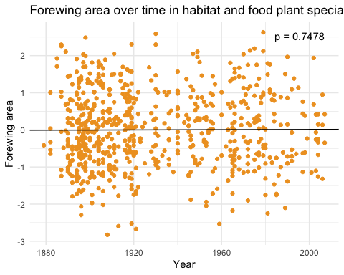

# Plot the forewing area over time  
ggplot(group_GS, aes(x = Year, y = Z_Forewing_Area)) +  
 geom_point(color = "#EFA028") + # Scatter plot  
 labs(title = "Forewing area over time in habitat generalists and food plant specialists",  
 x = "Year",  
 y = "Forewing area") +  
 theme_minimal() + # Optional: Adjust the theme if needed  
 # Calculate linear regression  
 geom_abline(slope = coef(lm(Z_Forewing_Area ~ Year, data = group_GS))[2],  
 intercept = coef(lm(Z_Forewing_Area ~ Year, data = group_GS))[1],  
 color = "black") +  
 annotate(  
 "text",  
 x = max(group_GS$Year),  
 y = max(group_GS$Z_Forewing_Area),  
 label = paste("p =", formatC(0.0001948, digits = 4)),  
 hjust = 1,  
 vjust = 1,  
 color = "black"  
 )

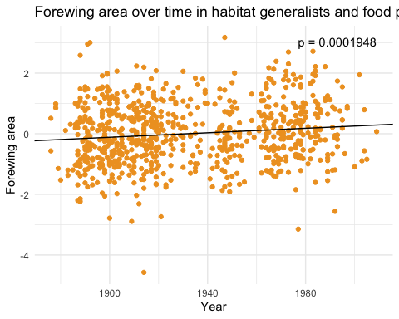

# Plot the forewing area over time  
ggplot(group_GG, aes(x = Year, y = Z_Forewing_Area)) +  
 geom_point(color = "#EFA028") + # Scatter plot  
 labs(title = "Forewing area over time in habitat and food plant generalists",  
 x = "Year",  
 y = "Forewing area") +  
 theme_minimal() + # Optional: Adjust the theme if needed  
 # Calculate linear regression  
 geom_abline(slope = coef(lm(Z_Forewing_Area ~ Year, data = group_GG))[2],  
 intercept = coef(lm(Z_Forewing_Area ~ Year, data = group_GG))[1],  
 color = "black") +  
 annotate(  
 "text",  
 x = max(group_GG$Year),  
 y = max(group_GG$Z_Forewing_Area),  
 label = paste("p =", formatC(0.0003496, digits = 4)),  
 hjust = 1,  
 vjust = 1,  
 color = "black"  
 )

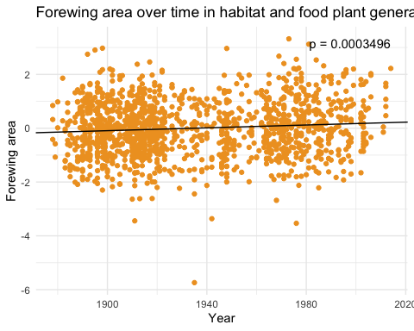

# Plot the abdomen width over time  
ggplot(group_SS, aes(x = Year, y = Z_Abdomen_Width)) +  
 geom_point(color = "#2895F5") + # Scatter plot  
 labs(title = "Abdomen width over time in habitat and food plant specialists",  
 x = "Year",  
 y = "Abdomen width") +  
 theme_minimal() + # Optional: Adjust the theme if needed  
 # Calculate linear regression  
 geom_abline(slope = coef(lm(Z_Abdomen_Width ~ Year, data = group_SS))[2],  
 intercept = coef(lm(Z_Abdomen_Width ~ Year, data = group_SS))[1],  
 color = "black") +  
 annotate(  
 "text",  
 x = max(group_SS$Year),  
 y = max(group_SS$Z_Abdomen_Width),  
 label = paste("p =", formatC(0.97486 , digits = 4)),  
 hjust = 1,  
 vjust = 1,  
 color = "black"  
 )

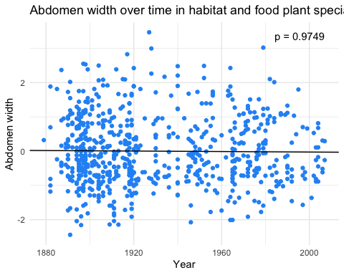

# Plot the abdomen width over time  
ggplot(group_GS, aes(x = Year, y = Z_Abdomen_Width)) +  
 geom_point(color = "#2895F5") + # Scatter plot  
 labs(title = "Abdomen width over time in habitat generalists and food plant specialists",  
 x = "Year",  
 y = "Abdomen width") +  
 theme_minimal() + # Optional: Adjust the theme if needed  
 # Calculate linear regression  
 geom_abline(slope = coef(lm(Z_Abdomen_Width ~ Year, data = group_GS))[2],  
 intercept = coef(lm(Z_Abdomen_Width ~ Year, data = group_GS))[1],  
 color = "black") +  
 annotate(  
 "text",  
 x = max(group_GS$Year),  
 y = max(group_GS$Z_Abdomen_Width),  
 label = paste("p =", formatC(7.253e-06 , digits = 4)),  
 hjust = 1,  
 vjust = 1,  
 color = "black"  
 )

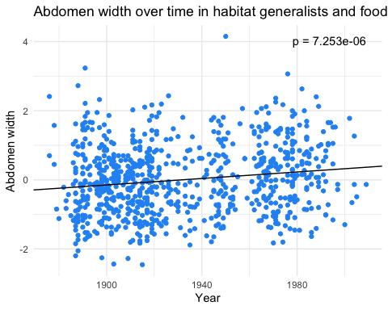

# Plot the abdomen width over time  
ggplot(group_GG, aes(x = Year, y = Z_Abdomen_Width)) +  
 geom_point(color = "#2895F5") + # Scatter plot  
 labs(title = "Abdomen width over time in habitat and food plant generalists",  
 x = "Year",  
 y = "Abdomen width") +  
 theme_minimal() + # Optional: Adjust the theme if needed  
 # Calculate linear regression  
 geom_abline(slope = coef(lm(Z_Abdomen_Width ~ Year, data = group_GG))[2],  
 intercept = coef(lm(Z_Abdomen_Width ~ Year, data = group_GG))[1],  
 color = "black") +  
 annotate(  
 "text",  
 x = max(group_GG$Year),  
 y = max(group_GG$Z_Abdomen_Width),  
 label = paste("p =", formatC(0.0007981 , digits = 4)),  
 hjust = 1,  
 vjust = 1,  
 color = "black"  
 )

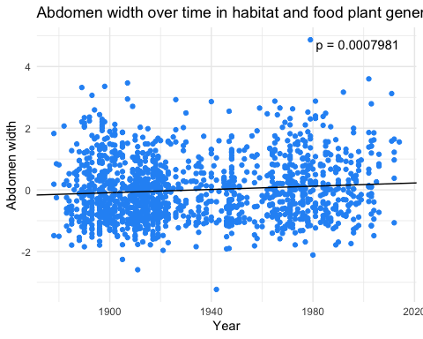

Look at trends within family over time

# Plot Z_Forewing_Area over time, colored by Family with trend lines only  
ggplot(Project_data_copynew, aes(x = Year, y = Z_Forewing_Area, color = Family)) +  
 geom_smooth(method = "lm", se = FALSE) + # Add linear trend lines  
 scale_color_manual(values = c("#F5AA0D", "#AA51DC", "#045A8A", "#0E6711", "#67070F")) + # You can specify colors as per your preference  
 labs(x = "Year", y = "Forewing Area", title = "Forewing Area Over Time by Family")

## `geom_smooth()` using formula = 'y ~ x'

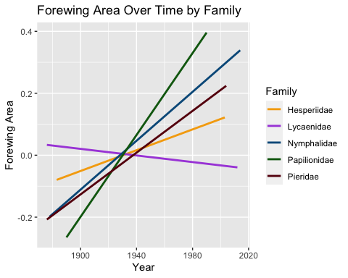

ggplot(Project_data_copynew, aes(x = Year, y = Z_Abdomen_Width, color = Family)) +  
 geom_smooth(method = "lm", se = FALSE) + # Add linear trend lines  
 scale_color_manual(values = c("#F5AA0D", "#AA51DC", "#045A8A", "#0E6711", "#67070F")) + # You can specify colors as per your preference  
 labs(x = "Year", y = "Abdomen Width", title = "Abdomen Width Over Time by Family")

## `geom_smooth()` using formula = 'y ~ x'

